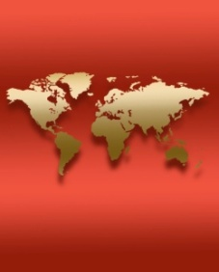
World Cinema Series

This Spring 2023 On-line,
Available for 24hrs, from Tuesdays @ 3pm

January 31 | Paraíso (Paradise), Spanish
February 7 | Стиляги (Hipsters), Russian
February 14 | ذیب (Theeb), Arabic
February 21 | I nostri ragazzi (The Dinner), Italian
February 28 | A que horas ela volta? (The Second Mother), Portuguese
March 14 | Die Göttliche Ordnung (The Divine Order), German
March 21 | Dios (God), Spanish
March 28 | Aguirre Der Zorn Gottes (Aguirre the Wrath of God), German
April 4 | 다른 나라에서 (In Another Country), Korean
April 11 | 洞 (The Hole), Chinese
April 18 | Le million (The Million), French
April 25 | 日本のいちばん長い日 (Emperor in August), Japanese

All Are Welcome!
Sponsored by the Department of Modern Languages & Cultures
Email Rosario_Colchero@baylor.edu for more information.

